**EXPRESS.JS MULTIPART FORM-DATA REST CLIENT**

REF:

<https://github.com/request/request#forms>

<https://www.npmjs.com/package/form-data>

<https://www.npmjs.com/package/request>

<https://stackoverflow.com/questions/17121846/node-js-how-to-send-headers-with-form-data-using-request-module>

<https://medium.com/@jxstanford/django-rest-framework-file-upload-e4bc8de669c0>

IN ORDER TO SEND MULTIPART/FORM-DATA TO OUR DJANGO-REST-FRAMEWORK API FROM NODEJS, FIRST WE HAVE TO INSTALL SOME MODULES USING NPM ON EXPRESS.JS APP:

1. ***npm install form-data --no-bin-links –save***

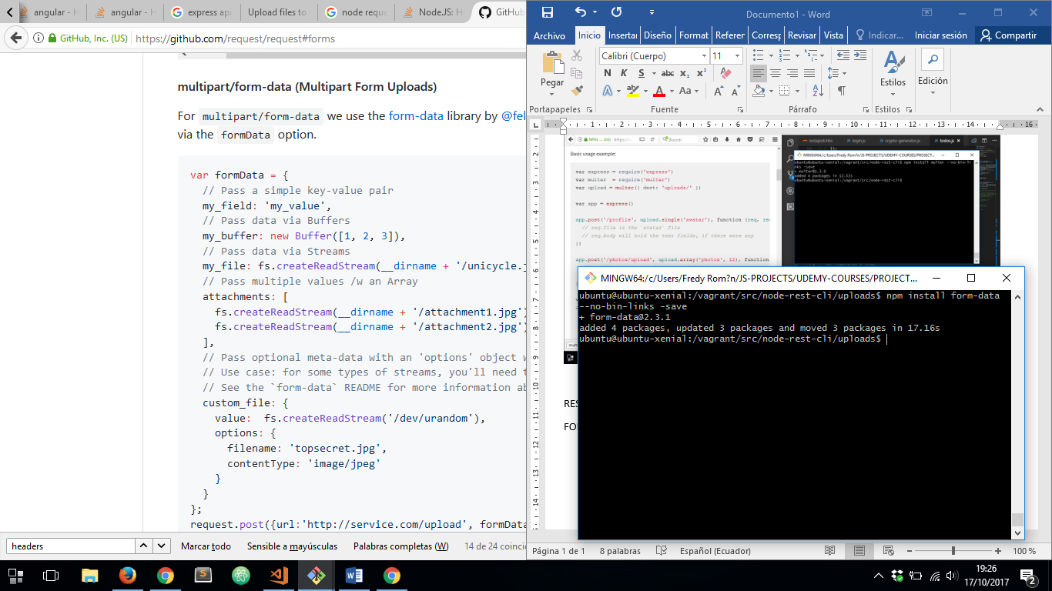

1. ***npm install request --no-bin-links –save***

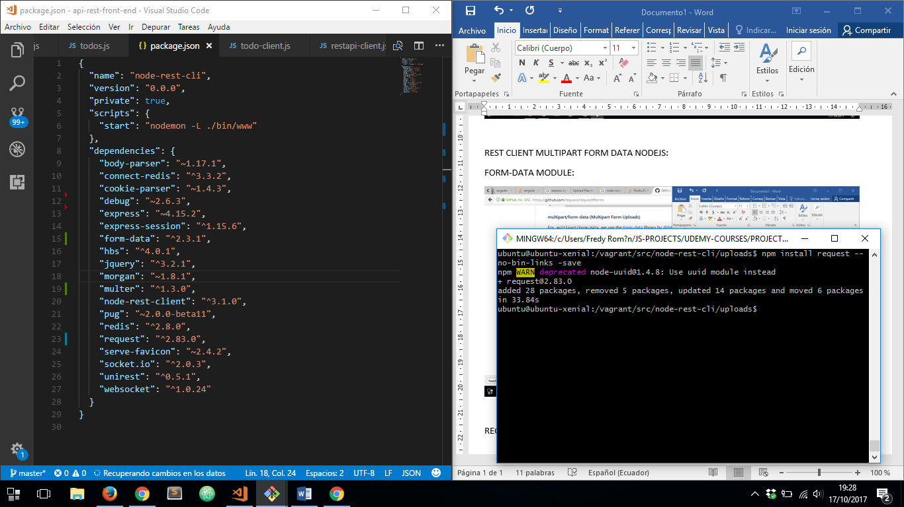

1. ***npm install node-uuid --no-bin-links –save***

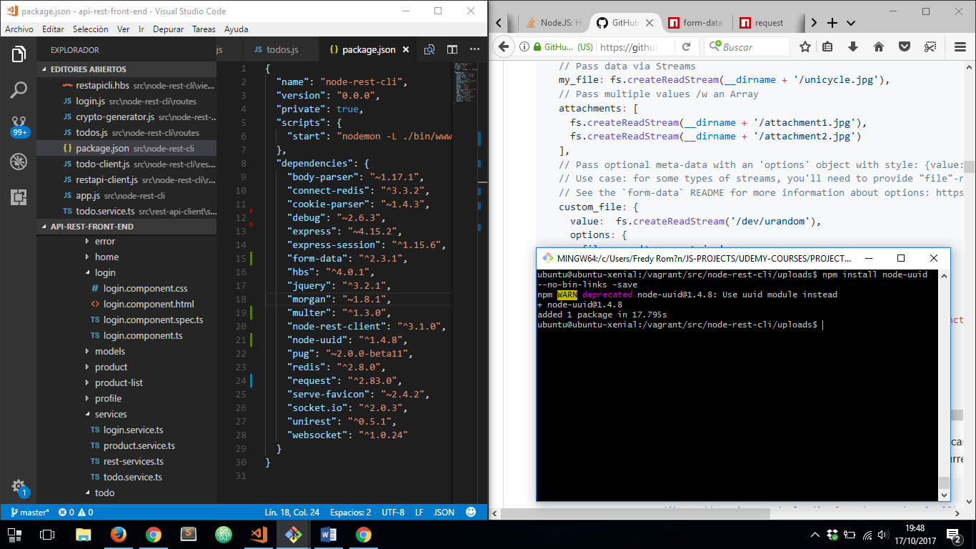

***package.json*** FILE

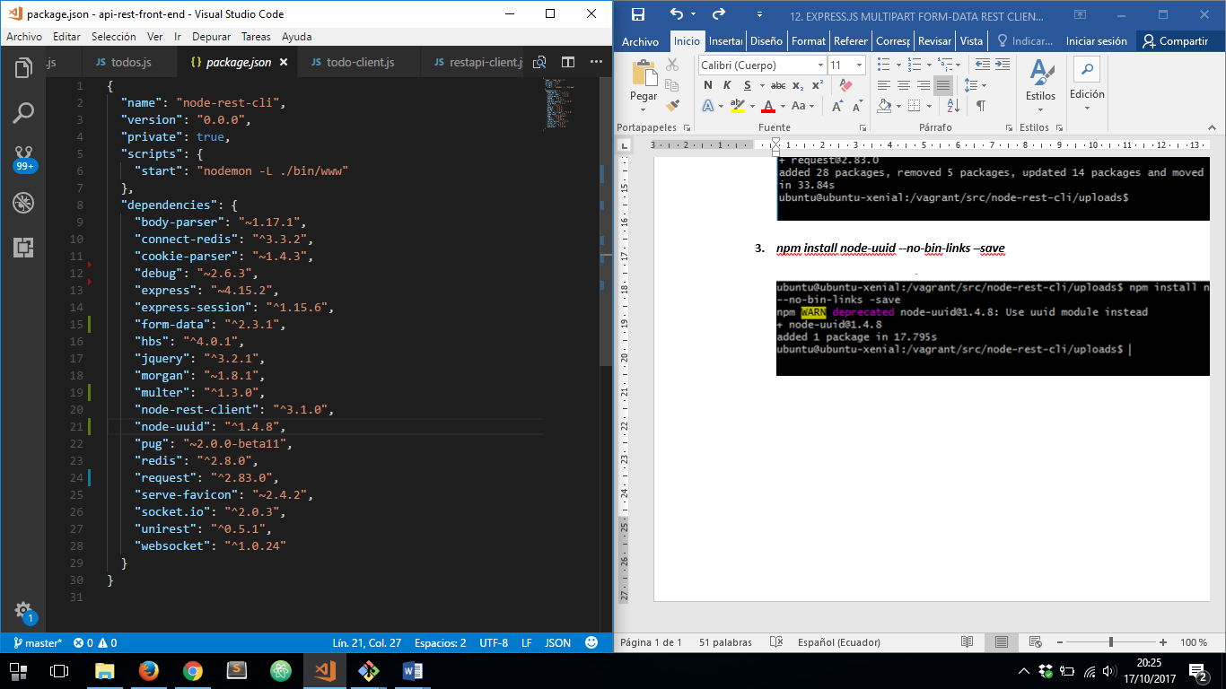

ONCE THEY INSTALLED, WE CAN USE THEM TO ACHIEVE OUR GOAL:

LET’S CREATE A NEW ROUTE NAMED ***todo.js***

1. IMPORT ***fs*** MODULE LINKED TO ***form-data*** MODULE
2. IMPORT ***request*** MODULE
3. CREATING FORM DATA
4. POST REQUEST USING REQUEST MODULE

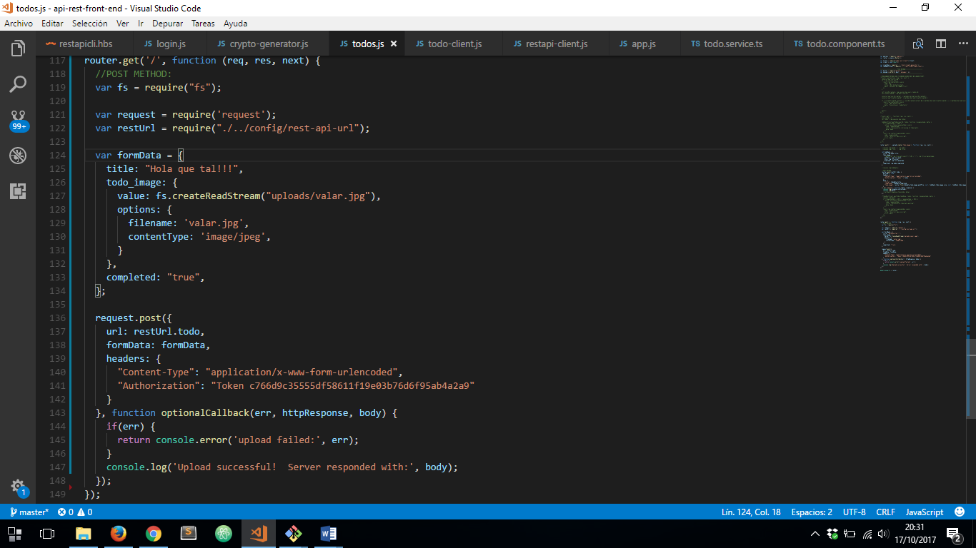

NEXT LINE CORRESPONDS TO OUR FILE LOADED WITH ***fs*** MODULE LINKED TO ***form-data*** MODULE:



WHICH IS LOCATED HERE:

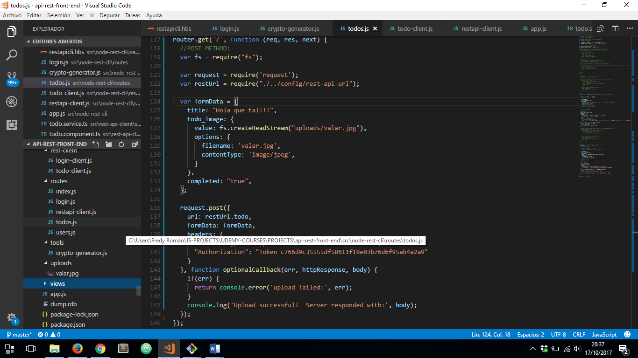

**NOTICE:**IT’S NECESSARY TO CONFIGURE OUR ***view.py*** FILE TO ACCEPT ***multipart/form-data*** AND ***x-www-form-urlencoded***

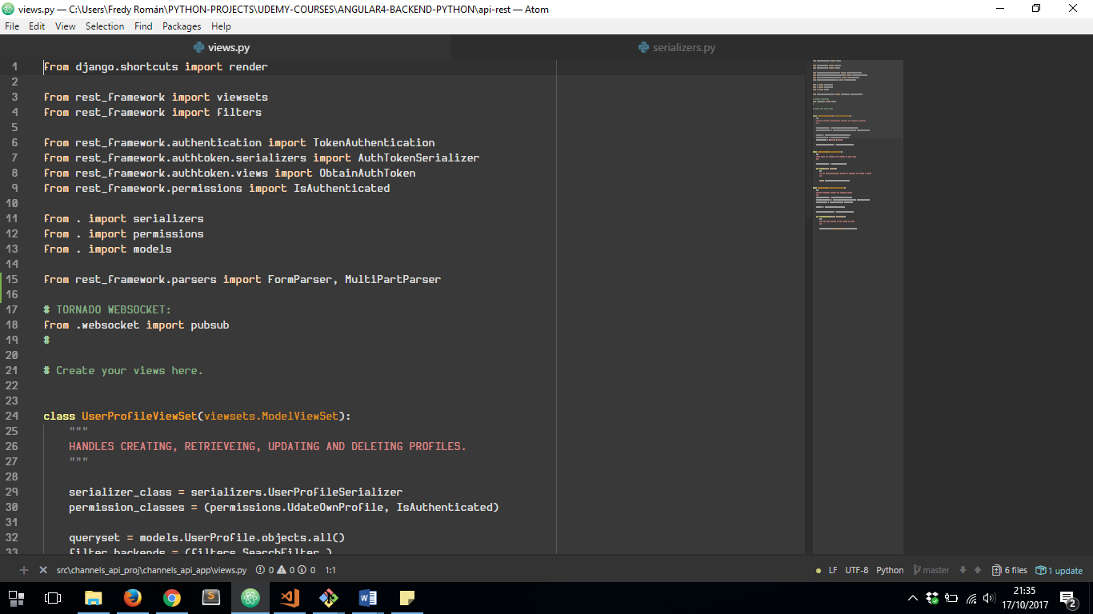

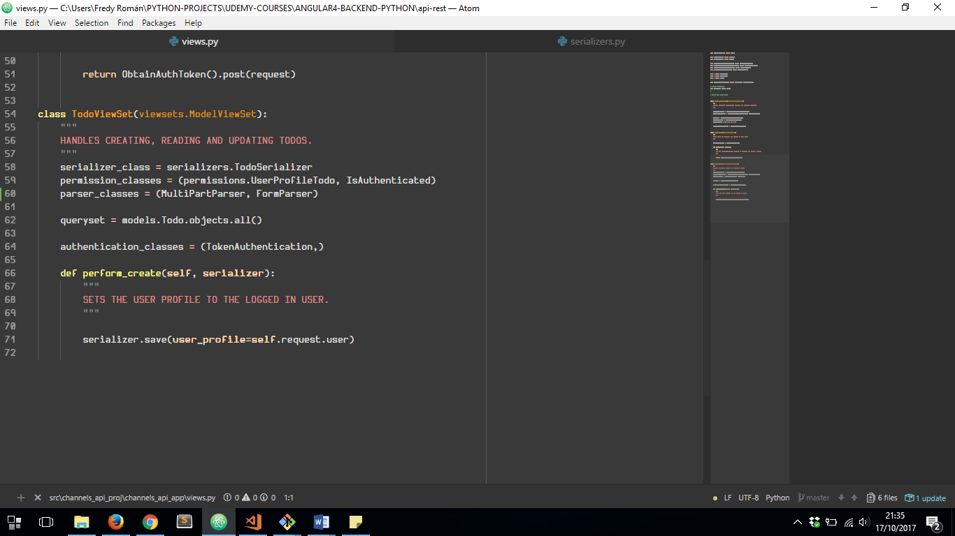

LET’S RUN THIS WITH ***npm install –host=0.0.0.0***:

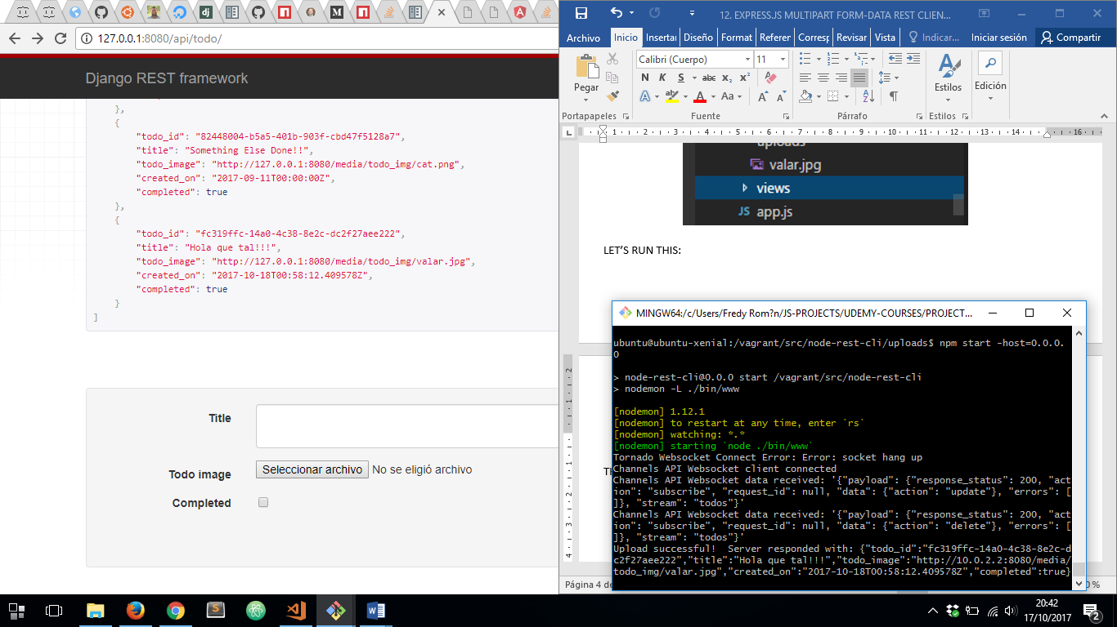

THE RESULT IS:

